R E T U R N I N G TO W O R K
S A F E L Y A F T E R C O V I D - 1 9
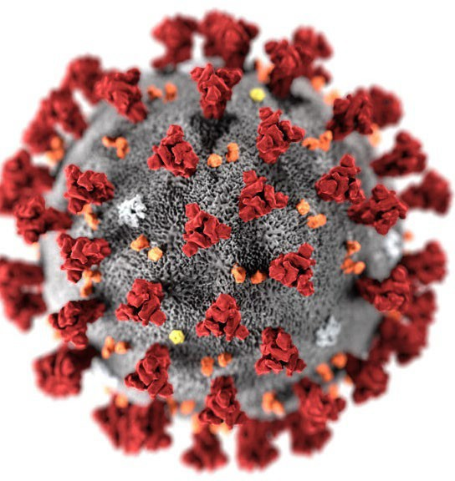

C O U R S E D E S C R I P T I O N
- As not only our industry but our world has been impacted with COVID – 19, it is necessary for us to understand safety procedures on a higher level. This course will present information on a view of infections and identifying potential problem areas in the office and recommended corrections.
- Various types of personal protection equipment will be discussed for all involved. (As the CDC and OSHA will be changing some recommendations, the information will be updated as needed in this course.)

L E A R N I N G
O U T C O M E S / O B J E C T I V E S
- At the conclusion of this course, the participant should be able to understand, discuss and implement hygienic protocol in the office and personally to ensure a safer environment.

- At the completion of this course, the participant should be able to:

  - Effectively demonstrate an understanding of the overall hygienic procedures
  - Have a better understanding of the how infections are spread including COVID - 19
  - Identify and correct problem areas in the practice that need better monitoring

D I S C L A I M E R
- While this information is useful, it is not to be considered any type of legal advice or absolute.
- Information included in this presentation is as close to accurate at the point of writing. Due to the daily changes, there could be information that could need to be updated.
- Information is included from the CDC, EPA, OSHA, FDA and Optical sites.
- Most information from Optical sites is ultimately from CDC, EPA and/or FDA.
- Most of these organizations ultimately link to each other.

W H AT I S C O V I D - 1 9
- COVID-19 is an acronym. In its full form, COVID-19 stands for coronavirus disease of 2019.
- COVID-19 is the name given by the World Health Organization (WHO) on February 11, 2020 for the disease caused by the novel coronavirus SARS-CoV-2.
- COVID-19 is considered a “novel” coronavirus
  - A “novel” coronavirus means that it is a new coronavirus that has not been previously identified in humans. This means it is different from coronaviruses that cause the common cold, and those that caused SARS in 2002 and MERS in 2012.
    - Like, SARS and MERS, the novel coronavirus is a zoonotic disease. The definition of a zoonotic disease is one that begins in animals and is transmitted from animals to people.

D I F F E R E N C E B E T W E E N
I N F L U E N Z A A N D C O V I D - 1 9
- Both are contagious respiratory illnesses
  - But are caused by different viruses
  - Flu is caused by infection with influenza viruses
  - COVID-19 is caused by infection with a “new” coronavirus (SARS-CoV-2)

- Some symptoms are similar
  - Confirmation is by testing

S Y M P T O M S
- Symptoms may appear 2-14 days after exposure to the virus. People with these symptoms may have COVID-19 – Usually symptoms take longer than with flu. Flu is generally 1-4 days
  - Fever or chills
  - Cough
  - Shortness of breath or difficulty breathing
  - Fatigue
  - Muscle or body aches
  - Headache
  - New loss of taste or smell

S Y M P T O M S
  - New loss of taste or smell
  - Sore throat
  - Congestion or runny nose
  - Nausea or vomiting
  - Diarrhea
  - Skin changes
  - Confusion (mostly in elderly with severe infections)
  - Eye problems
    - Enlarged, red blood vessels, swollen eyelids, excessive watering and increased discharge. The infection also might cause light sensitivity and irritation. These symptoms are more common in people with severe infections.

S Y M P T O M S
- For both COVID-19 and flu, it’s possible to spread the virus for at least 1 day before experiencing any symptoms.

- Persons with COVID-19 are generally contagious longer than persons with flu

- How long someone can spread the virus that causes COVID-19 is still under investigation.
- It’s possible for people to spread the virus for about 2 days before experiencing signs or symptoms and remain contagious for at least 10 days after signs or symptoms first appeared. If someone is asymptomatic or their symptoms go away, it’s possible to remain contagious for at least 10 days after testing positive for COVID-19.

S Y M P T O M S
- Look for emergency warning signs for COVID-19.
- If someone is showing any of these signs, seek emergency medical care immediately:
  - Trouble breathing
  - Persistent pain or pressure in the chest
  - New confusion
  - Inability to wake or stay awake
  - Bluish lips or face

H O W C O V I D - 1 9 A N D F L U A R E
S P R E A D
- Both are spread in similar ways
  - Spread is more likely when people are in close contact with one another (within about 6 feet).
  - Person to person through respiratory droplets
    - Coughs, sneezes, laughing, talking
    - Surface contact, etc.
  - COVID-19 is more contagious than flu

  - COVID-19 spreads quickly and to more people groups

P E R S O N S AT H I G H E R R I S K
- Both COVID-19 and flu illness can result in severe illness and complications. Those at highest risk include:
  - Older adults
  - People with certain underlying medical conditions
  - Pregnant women

C O M P L I C AT I O N S
- Both COVID-19 and flu can result in complications, including:
  - Pneumonia
  - Respiratory failure
  - Acute respiratory distress syndrome (i.e. fluid in lungs)
  - Sepsis
  - Cardiac injury (e.g. heart attacks and stroke)
  - Multiple-organ failure (respiratory failure, kidney failure, shock)
  - Worsening of chronic medical conditions (involving the lungs, heart, nervous system or diabetes)
  - Inflammation of the heart, brain or muscle tissues
  - Secondary bacterial infections (i.e. infections that occur in people who have already been infected with flu or COVID-19)

C L E A N I N G A N D D I S I N F E C T I N G
- Difference between cleaning and disinfecting
  - Cleaning with soap and water removes germs, dirt, and impurities from surfaces.
    - It lowers the risk of spreading infection.
  - Disinfecting kills germs on surfaces.
    - By killing germs on a surface after cleaning, it can further lower the risk of spreading infection.

C L E A N I N G
- Vacuuming
  - First off – eliminate any small area floor rugs
  - Use vacuum with high-efficiency particulate air (HEPA) filter
  - Do NOT vacuum room with other people in it
    - The person vacuuming should wear adequate PPE
  - Consider temporarily turning off room fans and the central HVAC system that services the room or space, so that particles that escape from vacuuming will not circulate throughout the facility.
    - Do NOT leave HVAC system off as it will help with recirculating clean air

C L E A N I N G
- Surfaces frequently touched by multiple people, such as door handles, bathroom surfaces, and handrails, should be cleaned with soap and water or another detergent at least daily when facilities are in use.
  - Cleaning removes dirt and impurities, including germs, from surfaces. Cleaning alone does not kill germs, but it reduces the number of germs on a surface.
  - Cleaning does not kill germs, but by removing them, it lowers their numbers and the risk of spreading infection.
    - If a surface may have gotten the virus on it from a person with or suspected to have COVID-19, the surface should be cleaned and disinfected. Disinfecting kills germs on surfaces.

C L E A N I N G
- Wear disposable gloves to clean and disinfect.
  - CDC recommends that persons who clean to also use disposable gowns and masks for protection.
- Clean surfaces using soap and water, then use disinfectant.
- Cleaning with soap and water reduces number of germs, dirt and impurities on the surface. Disinfecting kills germs on surfaces.
- Practice routine cleaning of frequently touched surfaces.
  - More frequent cleaning and disinfection may be required based on level of use.
  - Surfaces and objects in public places, such as shopping carts and point of sale keypads should be cleaned and disinfected before each use.
C L E A N I N G
L O O K A T A L L A R E A S O F T H E O F F I C E F O R H I G H T O U C H

S U R F A C E S
- High touch surfaces include:
  - Tables
  - Doorknobs
  - Light Switches
  - Countertops
  - Handles
  - Desks, Phones
  - Keyboards
  - Toilets
  - Faucets
  - Sinks, Etc.
- Chairs
- Chair arms
- ALL parts of exam instruments
  - Example – slit lamp where patient may hold on to side of slit lamp
  - Example – on/off knobs on equipment
  - Clipboards – eliminate if possible
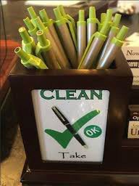

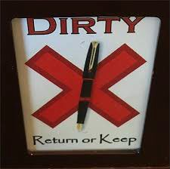

W H O S H O U L D C L E A N
  - According to the CDC, regular cleaning staff can clean and disinfect community spaces.
  - Cleaning staff should be trained on appropriate use of cleaning and disinfection chemicals and provided with the personal protective equipment (PPE) required for the chemicals used.

  - HOWEVER, cleaning should be done throughout the day between patients and when changing rooms/areas by staff

D I S I N F E C T I N G

  - Recommend use of EPA-registered household disinfectantexternal icon
Follow the instructions on the label to ensure safe and effective use of the product. Many products recommend:
    - Keeping surface wet for a period of time (see product label).
      - Ranges in time from 1 minute (example – some hydrogen peroxide, not all) to 10 minutes (alcohol) 5 minutes (ammonia) and others up to 25 minutes. Some ethanol alcohol is as little as less than a second, so read instructions carefully
    - Precautions such as wearing gloves and making sure you have good ventilation during use of the product.
    - This website has a continuing list of products recommended for cleaning and are registered by EPA – there are 469 entries as of now.
      - https://www.epa.gov/pesticide-registration/list-n-disinfectants-use-against-sars-cov-2-covid- 19

E PA D I S I N F E C T I N G
R E C O M M E N D AT I O N S
  - Check that the product is EPA recommended
  - Read the directions for use
  - Pre-clean the surface if it is visibly dirty with soap and water
  - Follow the contact time
    - DO NOT wipe off until the time has been met
      - Disinfection takes appropriate time
  - Wear gloves and wash your hands
  - Keep in original containers if possible or label containers
  - Keep disinfecting solutions out of the reach of children

D I S I N F E C T I N G

  - Diluted household bleach solutions may also be used if appropriate for the surface
    - To make a bleach solution, mix:
    - 5 tablespoons (1/3rd cup) bleach per gallon of room temperature water OR
    - 4 teaspoons bleach per quart of room temperature water
  - Never mix any chemicals/solutions
  - Bleach solutions will be effective for disinfection up to 24 hours.
  - Alcohol solutions with at least 70% isopropanol or ethanol alcohol may also be used.

C L E A N I N G A N D D I S I N F E C T I N G
E L E C T R O N I C S
  - For electronics, such as tablets, touch screens, keyboards, remote controls, and ATM machines
  - Consider putting a wipeable cover on electronics.
  - Follow manufacturer’s instruction for cleaning and disinfecting.
    - If no guidance, use alcohol-based wipes or sprays containing at least 70% alcohol. Dry surface thoroughly.

A LT E R N AT I V ED I S I N F E C T I O N
M E T H O D S
  - The efficacy of alternative disinfection methods, such as ultrasonic waves, high intensity UV radiation, and LED blue light against COVID-19 virus is not known.
    - EPA does not routinely review the safety or efficacy of pesticidal devices, such as UV lights, LED lights, or ultrasonic devices. Therefore, EPA cannot confirm whether, or under what circumstances, such products might be effective against the spread of COVID-19.
  - CDC does not recommend the use of sanitizing tunnels. There is no evidence that they are effective in reducing the spread of COVID-19. Chemicals used in sanitizing tunnels could cause skin, eye, or respiratory irritation or damage.
  - CDC only recommends use of the surface disinfectants identified on List Nexternal iconexternal icon against the virus that causes COVID-19.

E X P O S U R E P R O T O C O L
  - Entire business doesn’t need to close but …
    - Areas used by sick person should be thoroughly cleaned and sanitized and left vacant for 24 hours.
    - If possible, open windows to allow fresh air to circulate
      - Adhere to any safety concerns

  - Once properly disinfected, workers who have had no exposure to sick person can return to work

R E D U C EO F F I C E T O U C H A B L E
S U R FA C E S
  - Evaluate office décor
  - If you use videos, loops, etc. ensure that only staff has access to devices for changing, etc.
  - Remove what is NOT absolutely necessary
    - Example – children’s treasure boxes, toys, coloring books, etc.
    - Example – Excessive POP merchandising
    - Remove books and magazines
    - Reduce number of chairs in reception area
      - Since fewer people will be allowed in at one time, this will allow for less need for sanitizing
    - At all times 6 feet minimum spacing is required between individuals

E X T R A P R E C A U T I O N S
  - Consider plexiglass divider to separate reception from patients.
  - Frequently clean door handles, clipboards, pens, chairs, etc.
  - Consistently clean all computers, keyboards, phones.

T E R M S F O R H A N D S A N I TAT I O N
  - Hand hygiene
    - A general term that applies to either handwashing, antiseptic hand wash, antiseptic hand rub, or surgical hand antisepsis.
  - Handwashing
    - Washing hands with plain (i.e., non-antimicrobial) soap and water.
  - ABHR – alcohol-based hand rub
    - Designed to reduce the number of microorganisms on the hands. In US, they contain 60-95% ethanol or isopropanol alcohol.
  - Antiseptic handwash
    - Washing hands with water and soap or other detergents containing an antiseptic agent.
  - Antiseptic hand rub
    - Applying an antiseptic hand-rub product to all surfaces of the hands to reduce the number of microorganisms present.

H A N D W A S H I N G
  - CDC guidelines
    - Faucets should be disinfected after EACH use.
    - Wet hands with clean, running water, apply soap (may turn off water)
    - Lather hands by rubbing them together with the soap
      - Lather backs of hands, between fingers and under nails
      - Scrub at least 20 seconds
      - Rinse hands well under running water
      - Dry hands using a clean towel (never been used) or air dry them

H A N D W A S H I N G
  - CDC guidelines
    - When possible, doctors and staff wash hands in presence of patients…
    - Hand washing is critical before any interaction with patients
      - Certainly prior and after eating and using the restroom
    - Hand sanitizers should be available for the patient as they enter the office or at the front desk and they should be instructed to use it when entering and upon leaving the office.
    - Patients should also be instructed to wash their hands prior to handling contact lenses
  - Keep hand sanitizers away from fire or flame

P E R S O N A L P R O T E C T I V E
E Q U I P M E N T( P P E )
  - A surgical mask, eye protection (goggles, protective eyewear with solid side shields, or a full-face shield), a gown or protective clothing, and gloves
    - During procedures likely to generate splashing or spattering of blood or other body fluids.

P E R S O N A L P R O T E C T I V E
E Q U I P M E N T( P P E )
  - A surgical mask, eye protection (goggles, protective eyewear with solid side shields, or a full-face shield), a gown or protective clothing, and gloves
    - During procedures likely to generate splashing or spattering of blood or other body fluids.

P E R S O N A L P R O T E C T I V E E Q U I P M E N T
( P P E ) – F O R E Y E C A R E O F F I C E S
  - A surgical mask, eye protection (goggles, protective eyewear with solid side shields, or a full-face shield), and gloves
    - During procedures not likely to generate splashing or spattering of blood or other body fluids.

E X A M P L EO F S O C I A L D I S TA N C E
R E F R A C T I O N
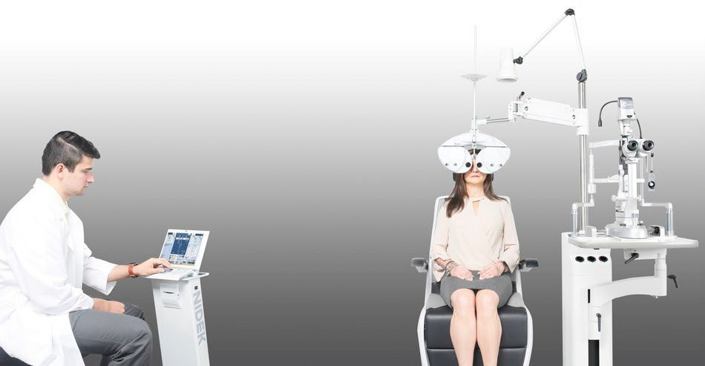

Social distancing does not replace masks and masks do not replace social distancing

D O C T O R / D O C T O R S & S TA F F
- Some jobs may be handled through telecommuting
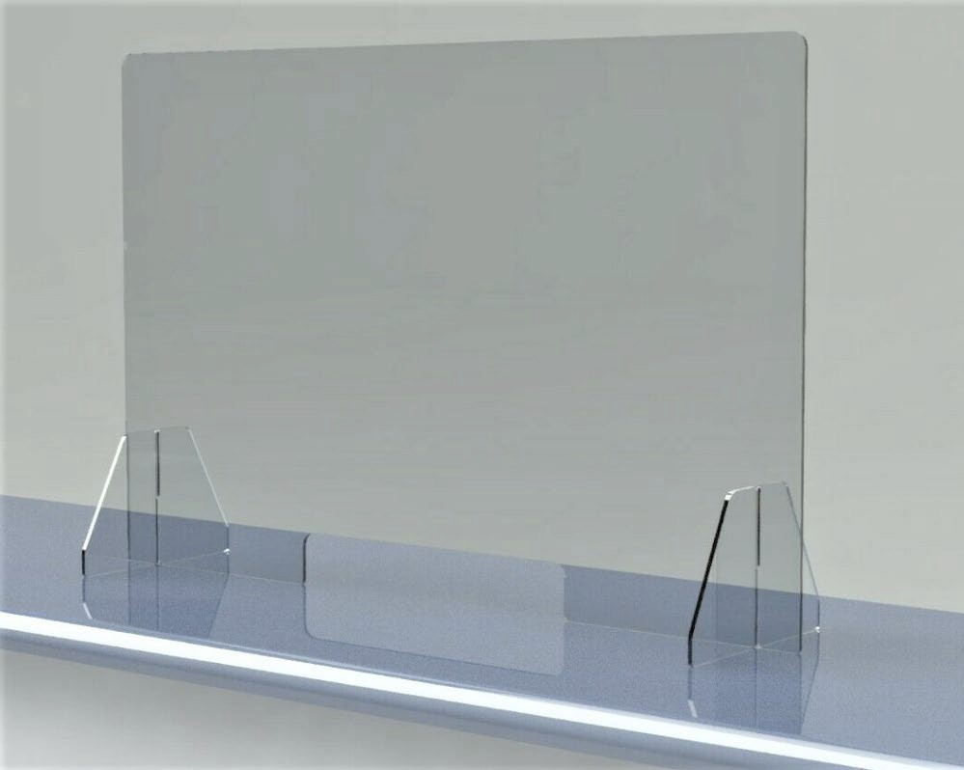

  - Scheduling, billing, etc.
- Don’t share workstations if at all possible
- Barrier protection - Use plastic/plexiglass dividers at front desk for check-in
- Provide training on infection control
- Temperature checks on staff EVERY day
  - Neither the OSH Act nor OSHA standards prohibits employer screening for COVID-19
- Report any health symptoms

D O C T O R / D O C T O R S & S TA F F
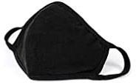
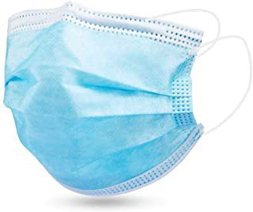
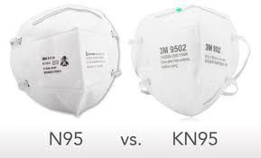
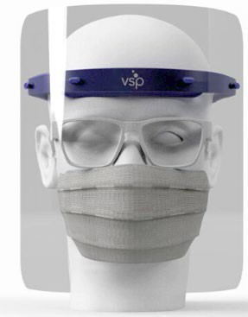
- Wear PPE at all times
- Masks

  - N95 and KN95 meet highest level of protection to wearer
  - Must cover nose and mouth
  - OSHA - Homemade masks don’t meet PPE guidelines
    - They protect other people not the individual wearing it
- Wrap around safety goggles or face shields – best protection is face shields
- Wear fresh disposable gloves with EACH patient
- When returning home, remove shoes and clothing before entering house and shower immediately
- Consider scrubs that can be washed every day.
- Consider a laundry service to launder staff scrubs
- Consider portals for payments and/or co-pays to decrease exposure at check-out.
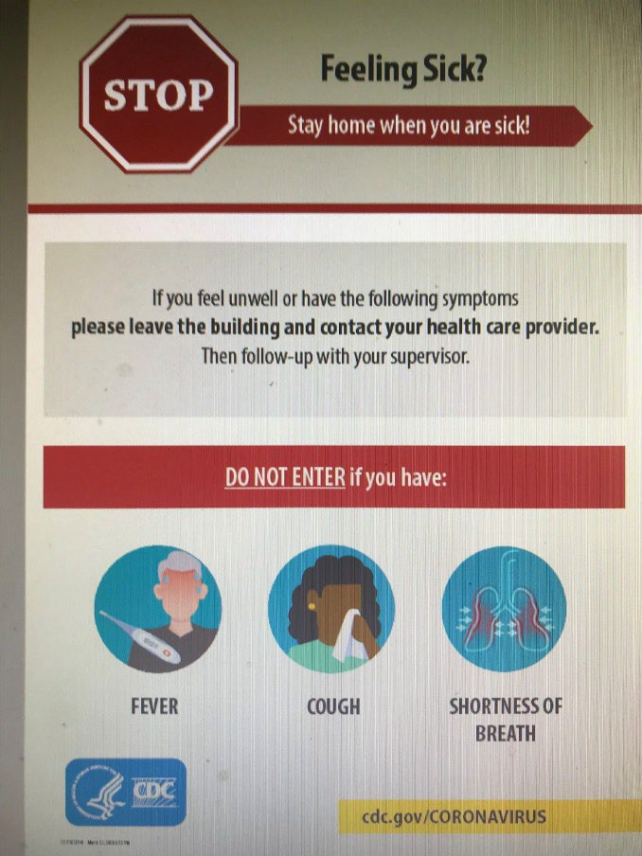

P O S T E R
T O P O S T

I N T E L L I G E N T S C H E D U L I N G
  - Begin at scheduling
    - Modify scheduling to provide additional time for room cleaning/sanitizing
    - Give highest priority to those in greatest need to include urgent patients, glaucoma and other disease patients in need of follow-up
    - Advise patients that when they arrive to call the office and they will be instructed when to come into office
      - Text or call back
      - Advise patients that they will have their temperature taken, prior to being admitted to office
      - Assign a staff member to escort patients to appropriate area

I N T E L L I G E N T S C H E D U L I N G
  - Begin at scheduling
    - Advise patients that it is recommended that they wear masks when coming in
      - Provide disposable masks for those not having one
    - Advise patients that number of people allowed in office will be limited at any one time
      - Only patient should come into office
        - Unless minor or need physical or mental assistance/support
    - Advise patients that you will verify their appointment one day prior and if you do not reach them, the appointment will be cancelled because you will need to verify their health and risk factors through questions

I N T E L L I G E N T S C H E D U L I N G
- Questions to ask patients prior to visit. Call to verify appt 1 day prior and ask then.
  - Advise them that if their condition changes, they need to reschedule

  - Are you feeling well?
  - Have you tested positive for COVID-19 or been exposed to someone who has?
  - Have you had a fever in the past 3 days?
  - Have you had a cough or shortness of breath in the past 3 days?
  - Have you had chest pain in the past 3 days?
  - Have you recently traveled to a high impact area such as New York, Detroit, Los Angeles, etc.?
  - Have you experienced a change in taste or smell recently?

F R A M E / C O N TA C TL E N S
S E L E C T & D I S P E N S E :
    - Consider frame dispenses by appointment only.
    - Limit the number of people in frame select area.
    - Ask enough questions to be able to limit the number of frames a patient can try on.
    - Disinfect all frames after contact according to EACH manufacturers recommendations
      - Otherwise, use soap and water and set aside to air dry
      - Use container to put all frames that have been tried on or handled
    - Use trial bottles of solution (not large bottles) and give to CL patient when done.
    - If possible, go to car to dispense glasses.
    - Mail contact lenses to patients.
    - Consider protective shield on pupilometer or using ruler to maximize distance.
      - Good idea includes to clean shield and pupilometer in front of patient.
      - Each time a patient sees an ECP practice good safety and hygiene, it reinforces it to them. It also ensures that they know the care the practice offers to their patients.

E X A M I N AT I O N
    - Wash hands and put on new gloves prior to each examination.
    - Always wear other PPE.
    - Take patient directly to examination room.
    - Disinfect occluder after each use.
    - Hold stereopsis and color test book for patient (don’t let patient touch it).
    - Use a protective shield on the slit lamp.
    - Avoid conversation when close to patient (during slit lamp examination or fundoscopy).
    - Use single-use protective coverings, if possible.

E X A M I N AT I O N
    - Non-contact tonometry may micro-aerosolize the virus.
    - Disinfect tonometer prism according to manufacturer’s guidelines.
    - Use binocular indirect or fundus photography to maximize distance during fundus examination.
    - Clean/disinfect equipment before and after each use, including chair and anything touched during examination.
    - Minimize specialty tests to critical needs (visual fields, optical coherence tomography, corneal topography, etc.).
    - Use touchless paper towel dispensers.

C L E A N I N G A N D D I S I N F E C T I N G
A G A I N
    - Look at EVERY piece of equipment and see whether it is touched by patients or touches patients
    - Slitlamps and any pretesting equipment should have all contact points cleaned and disinfected with single use alcohol wipes and allowed to air dry prior to each use.
    - CORNEAL REFLECTIVE PUPILMETERS should be cleaned and disinfected with single use alcohol wipes and allowed to air dry prior to each use.
    - Others

    - When disinfecting, think of the order.
      - Example – tonometer tip/prism should be disinfected with separate wipe – not after other parts of the instrument have been disinfected. The tip touches the patient’s eye

O T H E R S A F E T Y P R E C A U T I O N S
    - Provide training to staff
    - Provide signage for patient/customers to read regarding social distancing
    - Provide signage for staff regarding safety precautions
    - Limit occupancy to a number that can provide for social distancing
    - Restrict movement in hallways/corridors/etc. to adhere to social distancing policy
    - Limit number of people in break rooms, etc.
    - Reinforce information regarding PPE for staff

