OANY
Eye Invaders
By Linda Conlin, ABOC,NCLEC,FNAO

Eye Invaders: Acanthamoeba, Pseudomonas and Fusarium

Course description
This course discusses the organisms acanthamoeba, pseudomonas and fusarium. Each organism will be investigated individually as to how it affects the eye and how infections can be treated. Special considerations and precautions for contact lens wearers will be discussed.

Objectives
At the conclusion of this presentation, you will have learned about:
- The organisms - Acanthamoeba, Pseudomonas and Fusarium
- How each organism can infect the eye and the consequences of infection
- Current and proposed treatments for infections, how these organisms are resistant to treatment, and ocular immune privilege

Acanthamoeba
Acanthamoeba is a single celled organism, known as a protozoan, of the genus amoeba. Commonly found in soil, water, including chlorinated pools and tap water, and sewage, it can cause disease in humans. Because the organism is so common, most people have some exposure to it over a lifetime, although infection is rare. Infection can occur when acanthamoeba enters cuts, the nose, mouth or eyes, and can spread to the central nervous system (CNS). If CNS infection results in encephalitis, the survival rate is less than 5%.

The organism lives on and carries bacteria. Acanthamoeba’s life cycle consists of two phases: Trophozoite, the active feeding and reproduction phase, and a double-walled cyst, when the organism is dormant in adverse conditions, which contributes to the organism’s resiliency. Acanthamoeba is very resistant to freezing, alkalinity and acidity (PH) changes, chlorine, radiation, and many topical antimicrobials.

When acanthamoeba invades the eye, it results in acanthamoeba keratitis. Risk factors for infection include swimming or showering in contact lenses, rinsing or storing lenses in water, handling lenses with unwashed or wet hands, failing to disinfect lenses properly, failing to clean and dispose of contact lenses as scheduled, using non-sterile solutions and topping solution rather than using fresh solution. Infections are usually unilateral, and infection rates are the same by gender. Eighty-five percent of cases are associated with contact lens use. Although acanthamoeba infections are generally rare, they spiked in 2007 when a common brand name contact lens solution was found to be inefficient against the organism.

Incidence
Generally, the incidence of acanthamoeba keratitis is 1 in 10,000 contact lens wearers. That means if you see 25 contact lens patients per week, you will see a case of acanthamoeba keratitis about every 7 ½ years. But, if you see 40 contact lens patients per week, you will see this infection about every 5 years. The current increase in immune disorders could increase the incidence of infection because of suppressed immune systems. Changes in the environment can increase the infection rate, too. For example, flooding in the Midwest in the summer of 1993 led to the contamination of municipal water supplies and correlated with a dramatic increase in cases of acanthamoeba keratitis treated at the University of Iowa Department of Ophthalmology. Daily disposable contact lens wearers are at lowest risk for infection, with the incidence increasing among wearers of two-week disposables to monthly to annual lenses. Illegal contact lens sales also contribute to acanthamoeba infections. For example, a 19 year-old woman purchased color contacts at a flea market. She received no instruction on wear, care or cleaning, and so stored the lenses in tap water. She subsequently developed an acanthamoeba infection.

The image shows the characteristic ring of acanthamoeba keratitis.
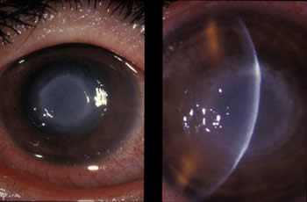
www.cdc.gov

Symptoms and diagnosis
Symptoms of acanthamoeba keratitis include sensation of something in the eye, eye pain, eye redness, blurred vision, sensitivity to light, and excessive tearing. The symptoms may wax and wane, leading some patients to believe the infection is getting better, but they cannot delay treatment. Infection is usually diagnosed by an eye doctor based on symptoms, a close-up eye exam that allows the eye doctor to see the amoebas, lab results from a scraping of the eye, and/or a swab for acanthamoeba DNA. It’s important to note that infection will not come from just one organism, but many. In the active phase, trophozoites reproduce every 8 to 24 hours.

Treatment
The full course of treatment can take up to a year. Treatments vary, but most include topical medications every hour while awake, combined with an oral antifungal. Resistant infections require additional topical medications around the clock, and possible IV therapy. With extensive damage to the cornea, transplant may be necessary. Currently, researchers are studying the efficacy of therapeutic contact lenses treated with plasma.

Pseudomonas aeruginosa
Pseudomonas is a bacteria that commonly causes many types of hospital infections. It adheres to biopolymers, the plastics used in medical devices such as catheters, drug delivery systems, wound closure, healing products and surgical implant devices. It is found widely in the environment, in soil, water, and plants, and thrives in warm, moist places – like the cornea. This bacteria is opportunistic, affecting the immunocompromised. It is the most common microorganism causing bacterial keratitis among contact lens wearers.

Pseudomonas can grow without oxygen or in distilled water, and temperatures of 107º. It is resistant to high concentrations of salts and dyes, weak antiseptics, and many commonly used antibiotics. The bacteria produces extracellular enzymes and toxins that break down physical barriers and damage host cells, and are resistant to host immune defenses. They are also capable of growth in diesel and jet fuel, where it is known as a hydrocarbon utilizing microorganism (or "HUM bug"), causing microbial corrosion in planes and machinery.

To make this invader even more formidable, the bacteria self-organize into a sticky, mat-like colony called a biofilm, which allows them to cooperate with each other, adapt to changes in their environment, and ensure their survival. Biofilms form within 24 hours.
Infection
Infections occur in contact lens wearers when bacteria stick to the contact lens surface or case, then multiply. The bacteria release molecules (toxins) causing inflammation and infection. It is interesting to note that those same pseudomonas toxins kill acanthamoeba, and can “melt” the cornea. The incidence in the general population is 2.76 per 10,000, with contact lens wearers at 13 per 10,000 – nearly five times the incidence. Symptoms include lid edema, thick discharge, corneal ulcer, redness and inflammation, and corneal swelling. Accurate diagnosis requires culturing.

In the eye, pseudomonas infection will spread concentrically and symmetrically.

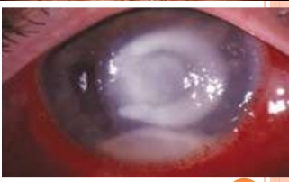
https://image.slidesharecdn.com/bacterialcornealulcer-140129095140-phpapp02/95/bacterial-corneal-ulcer-drbp-27-638.jpg?cb=1390990984
Treatment
Topical antibiotics are administered at 1 to 2 drops hourly for 48 hours, then every 4 hours until the lesion is healed. Corneal grafting may be needed to eradicate the organism or repair damage. Deeper infection may require vitrectomy, removal of the vitreous humor. In spite of the highly resistant nature of pseudomonas, nonsteroidal anti-inflammatory drugs (NSAIDs) reduce inflammation and help prevent bacterial colonization on biopolymers like contact lenses. In studies, molecularly imprinted, therapeutic contact lenses provided controlled release of medication over time at dosages similar to drops, but with greater efficacy.

Fusarium
Fusarium is a fungus found in soil and plants. It is most common in subtropical climates. Fusarium infection can be caused by a scratch or puncture from a plant. It reproduces by spores spread through air, equipment and water, and is not contagious, but spores can remain in the soil for many years.

Chronic ocular disease increases the risk of infection. What’s more, the incidence has increased over last 30 years due to the increase in immunodeficiency diseases, increased use of topical corticosteroids, and better diagnostics. Incidence also increases from northern to southern climates, and is common in developing countries. The incidence in the US is 4 to 21 per 10,000. Fusarium gains access to the cornea through a defect in the epithelium. The epithelium may be compromised by disease, trauma, foreign body, surgery or CL wear. Fusarium then spreads to Descemet’s membrane.

About 70 different fungi can cause fungal keratitis. It may infect internal eye structures and result in loss of the eye. It is difficult to treat because of the limited availability of antifungal agents that are compatible with the eye. Some treatment drugs may require a compounding pharmacy.

Symptoms and presentation
Symptoms include foreign body sensation, increasing pain, discomfort, sudden blurred vision, unusual redness, excessive tearing and discharge, and photophobia. Upon examination, patients can present with conjunctival injection, corneal ulcer, epithelial defect, abscess, stromal infiltrates with feathery margins, a white ring in the cornea, and/or a gray-white corneal opacity.

Fusarium infection can be difficult to diagnose. Corneal swabbing may be inadequate because the epithelium is often intact. Tests of corneal scraping should be sent for a polymerase chain reaction (PCR) and culture. Cultures usually take 1 to 35 days, and during that time the patient could be receiving the wrong treatment! A corneal biopsy may be needed.

Fungal infection after corneal transplant
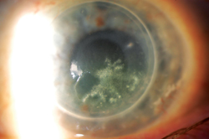
Review of Ophthalmology

Treatment
Fusarium infections are slow to develop, they may take weeks, but they are even slower to cure, which may take months. The infection usually goes deeper than bacterial infections, so treatment must be aggressive. The treatment regimen is topical antifungal drops used hourly around the clock for the first week, and then every two hours after. Daily or every other day medical visits during the hourly drops regimen are needed for monitoring. Because the epithelium may be intact and medicines can’t penetrate, epithelial scraping is required. Even so, medication fails 15 to 36% of the time, requiring a corneal graft.

Prevention
It is critical that contact lens patients receive proper instruction in the care and handling of their lenses. They must WASH THEIR HANDS before touching their eyes or the lenses. Daily disposables are better, but for those patients who use longer wear lenses, they must use fresh solution, rub the lenses even with “no-rub” solutions, and close bottle top between uses. They should scrub the lens case with a Q-Tip and contact lens solution weekly. Monthly, they should soak the case in hot water (158 degrees). Cases should then be air dried FACE DOWN on a clean surface as far away from the toilet as possible. Do you think many patients would do all of those things? It would be a good idea to give them extra cases!
This patient’s contact lens case had acanthamoeba, bacterial and fungal biofilm at the same time!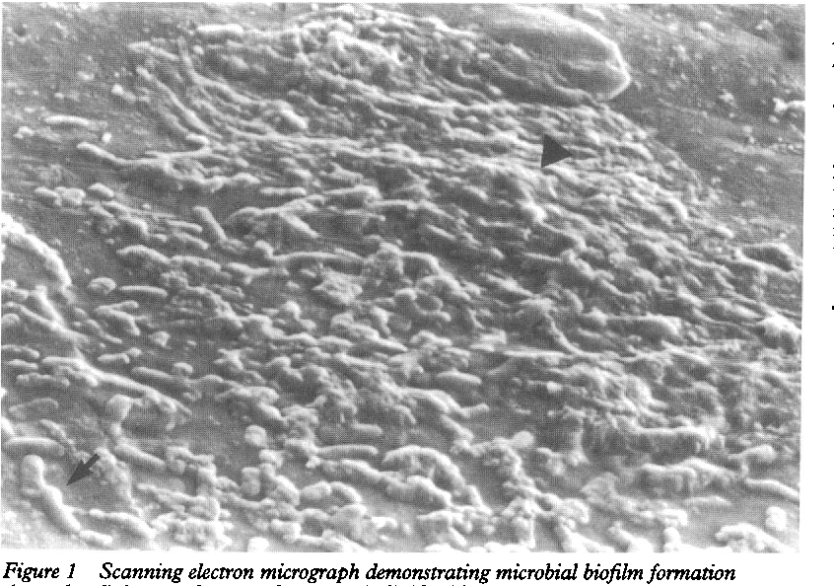
Semanticscholar.org

Patients also must be counseled about the dangers of purchasing contact lenses from unauthorized sources because they may be getting more than they bargained for. An inspection in July 2011 in Singapore found counterfeit Ciba Freshlook ColorBlends lenses in five optical shops. The lenses were packed in solution contaminated with pseudomonas. This occurred in spite of Singapore’s harsh punishment of a $100,000 fine and/or 3 years in prison.

Would you have noticed the difference?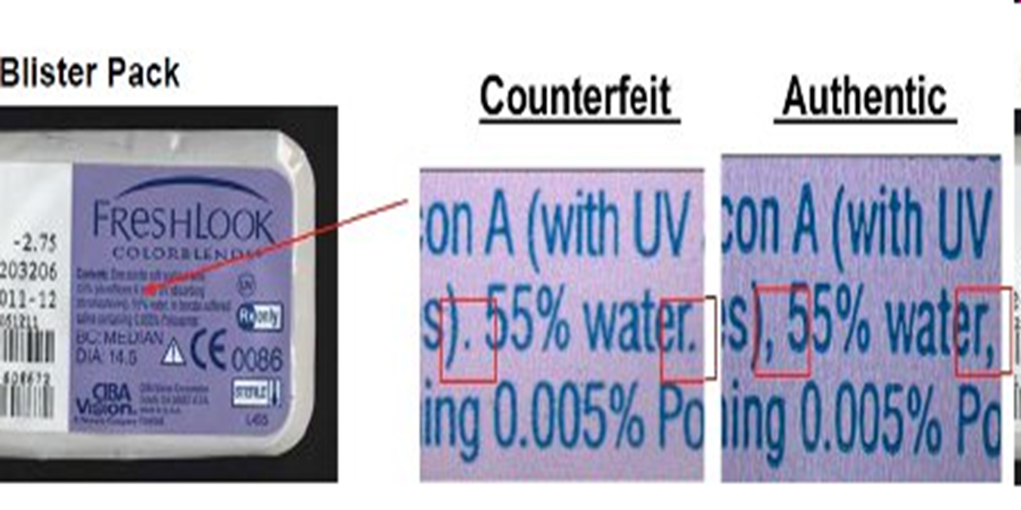
https://evonnz.com/spotting-counterfeit-freshlook-colorblends-contact-lenses/

In the US, authorities are cracking down on illegal sales of contact lenses, too. In January 2017, the owner of an online contact lens retailer was sentenced to almost four years in jail in the largest-ever case of its kind in the US. Las Vegas man Dmitriy Melnik had previously admitted to selling counterfeit colored contact lenses, sourced from China and South Korea, to unsuspecting customers without a prescription, from his Candy Color Lenses store. Some lenses were tested and found to be contaminated with potentially dangerous bacteria. Along with the 46 month jail term, 30-year-old Melnik will make $200,000 in restitution and forfeit $1.2 million in proceeds derived from the scheme, as well as property seized during the investigation. Apparently, it was a very lucrative business!

Illegal contact lenses are frequently imported by labeling them as a different, unregulated product. As recently as July 2019, a Florida woman, Son Chu Gilliam, pleaded guilty to charges that she bought bulk counterfeit contact lenses from China and sold them through her tattoo parlor. Lenses and packaging were separate, and labeled as an art video worth $20. Tests by the FDA found that the contact lenses were not genuine, FDA-approved product, and were also contaminated with hazardous bacteria.

These aren’t just isolated incidents. Researchers at the FDA's Forensic Chemistry Center in Ohio tested nearly 350 decorative, non-corrective contact lenses obtained without a prescription. An alarming 60% of the lenses tested positive for microbial contamination. And it isn’t only color lenses. Counterfeit contact lenses have been found online with almost any brand name.

Some legitimate online lens companies may be putting patients in jeopardy, too. A writer for Quartz, a business magazine, and four friends ordered lenses from a well-known online contact lens seller with a made up prescription from a made up doctor. They all received the lenses legally. While not contaminated, the unverified prescription lenses could cause harm. When offices shut down during the COVID pandemic, I called another well-known online lens seller. I told them I needed lenses, but my doctor’s office was closed and couldn’t verify the prescription. The representative asked if I knew what my prescription was. When I told her I did, she said they would attempt to contact the office, and if the office didn’t respond timely (8 business hours) they would issue a “passive authorization” and I could get my lenses. I could have ordered any kind in any prescription, legally.

As eyecare professionals we can help protect consumers from these illegal and dangerous businesses. Report brick and mortar illegal contact lens sellers to your state department of health or consumer protection. Report illegal online sellers to the FDA at https://www.accessdata.fda.gov/scripts/medwatch/.

Contact lens solutions
For patients who don’t use daily disposable lenses, proper use of cleaning solutions is critical. Patients must understand the time needed for solutions to effectively disinfect lenses, usually 4 to 6 hours. Soaking lenses for less time than what the manufacturer recommends increases the risk that not all microbes have been eliminated, and so infection risk increases when the lenses are reinserted.

For patients who are sensitive to solutions, a peroxide system provides excellent disinfection. Peroxide systems are preservative free, have a low incidence of corneal staining, oxidize microbes, break down protein and lipid bonds, and show the best acanthamoeba reduction. One step systems must have enough time to neutralize, however, presenting a risk to patients who try to cut the process short.

Peroxide systems also have a Catch-22. Acanthamoeba, pseudomonas and fusarium all have the enzyme catalase, which breaks down peroxide into water and oxygen. Peroxide kills the organism but the dead organism releases catalase that neutralizes the peroxide, reducing its efficacy. Peroxide solutions are therefore less effective on biofilms. Peroxide solution systems with a two-step cleaning and neutralizing process that provide longer exposure to the full strength solution are better, but the added neutralization step increases the risk of noncompliance.

The risks
Approximately 10% of infections from these organisms result in some type of vision loss. A study of more than 2,000 contact lens patients released in 2009 found the risk of infection was 5 to 10 times greater in overnight contact lens wear than in daily wear, and internet contact lens purchases were associated with increased risk of infection. In additional findings, new extended wear patients (less than 6 months) had an increased risk of infection. What’s more, early treatment is critical. More serious outcomes increased with a delay of treatment of only 12 hours to begin with, or longer.

Ocular immune privilege
The good news is the innate ability of the eye to fight infection. The cornea is naturally resistant to infection, it is the only body surface that doesn’t normally harbor bacteria, and tears have antibiotic properties. Infection occurs when the cornea is compromised.

The eye attempts to limit local immune and inflammatory responses to preserve vision. Ocular immune privilege is believed to protect the eye from day-to-day inflammatory damage. The structures of the eye are susceptible to damage from inflammation, such as vascular leakage, scar tissue and visual cells, and have limited ability to regenerate. Protection comes from physical barriers, the tight cell junctures within the layers of the cornea that prevent free entry and exit of cells, and even larger molecules, into and out of the eye. Immunosuppressive factors within the eye inhibit the activity of immune-competent cells, and the eye actively regulates systemic immune responses.

Cytokines are secreted by cells in the immune system
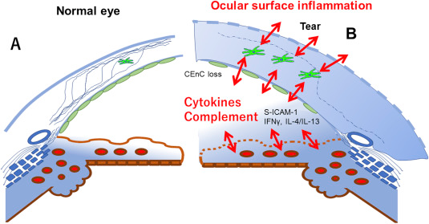
https://www.sciencedirect.com/science/article/pii/S1350946219300011

In addition, lymphoid tissue associated with the lacrimal gland that secretes tears is continuous from the lacrimal gland throughout the conjunctiva, circulating the naturally antibiotic tears. Mucous secretions from the lymphoid tissue protect the ocular surface and adnexa, the external structures of the eye. The purpose of immune privilege is to protect the area from damage that may occur with swelling and higher temperatures from the immune response. The eye limits its own inflammatory immune response so that vision isn’t harmed by swelling and other tissue changes. The high success rate of corneal transplants without blood and exact tissue match is attributed to ocular immune privilege.

The eye has other natural barriers to infection. The blood-retinal barrier in which the retinal pigment epithelium (RPE) forms a tight barrier, separates the retina from the blood stream. It’s interesting to note that RPE stem cells are being studied to heal age-related macular degeneration (AMD). Another natural barrier is the ciliary body epithelium, the thick connective tissue surrounding the iris vasculature.

Conclusion
While infection is unusual, three common microbes can cause sight-threatening eye disease and damage. These microbes have their own strong defenses which must be overcome. As a result, treatment is intense and long, and may not completely preserve sight. Extended lens wear, illegal contact lens sales and improper cleaning and handling of lenses increase the risk of infection. However, the eye has its own immune system, ocular immune privilege, because of the risks of inflammatory damage to the eye and the lack of blood supply that provides defense against infection for the rest of the body.

