OANY
GLAUCOMA: A PRIMER
By: Dr. Joseph Bacoti MD

Release Date: May 14th 2020
Expiration Date: Dec 31st 2021

Learning Objectives:
After completion of this course the reader should be able to
Describe what Glaucoma is
Describe the types of Glaucoma
Describe how Glaucoma is determined
Describe what happens to the eye from Glaucoma
Describe the means of Glaucoma treatment

Credit Statement:
This course is a Technical Level . This course is approved for a 1 Hour dual contact lens or Ophthalmic Dispensing course under the authority of the Opticians Alliance of New York Inc NYSED Lic # 071317-071220.17.

Upon completion of this course you will be directed to the certificate completion page. In the highlighted area of the certificate you will type in your first and last name as well as your NY State Lic#.. Then you can print out the Certificate.

There have been many changes over the years in what we know when it comes to glaucoma and the diagnosis and treatment of the disease. First, we need to rework our definition of the word glaucoma and what it means to the eye.

Glaucoma is a multifaceted, group of disease states of the eye that results in damage to the optic nerve of the eye and loss of vision. The damage to the optic nerve results in loss of vision, usually from the periphery and lastly as it progresses resulting in total vision loss, if not treated. Increased pressure or a buildup of pressure in the eye results in damage to the optic nerve, the blood vessels and the nerves passing thru the optic nerve. The changes in the optic nerve is called “cupping”, or changes in the appearance of the optic nerve over time. The pressure in the eye when measured with instruments is called the intraocular pressure or “IOP”. The diagnosis of glaucoma is made by observing these changes in the optic nerve cupping, these changes can occur with and sometimes without increased or high intraocular pressure. Changes in the appearance of the cupping and secondary changes in the visual field are hallmarks of glaucoma. Symptoms of glaucoma are generally not present or develop slowly, with the most common form of glaucoma, so the patient will not be aware that they actually have the disease. While there is no cure for glaucoma, early diagnosis and treatment can manage the disease and halt or reduce damage to the optic nerve and the chance for vision loss.

The optic nerve varies in its susceptibility to damage from the intraocular pressure and some people develop optic nerve damage at low pressures while others can have mildly elevated IOP and suffer no damage over many years. Glaucoma is a localized optic nerve disease that is characterized by; 1) optic nerve cupping; 2) changes in the optic nerve and vision due to the inability of the optic nerve to tolerate the IOP that is present; 3) loss of visual field and vision.

Glaucoma is a leading cause of blindness as the population increases in age. The disease of glaucoma is more common in families and as age increases for the patient. Ophthalmologists and optometrists would consider normal intraocular pressure to be less than 22 mmHg. Generally, the higher the intraocular pressure the more likely there will be damage or increased cupping of the optic nerve. Increased intraocular pressure makes it more likely the patient will develop glaucoma and loss of vision. Restated, glaucoma is a disease of the optic nerve resulting in increased cupping and changes in the visual field. There are some patients who have higher than 22 mmHg and do not have glaucoma, because there are no changes in the optic nerve. However, studies have shown that when the IOP is close to 30 mmHg or above there is greater risk of vision loss the higher the IOP.

A short review of basic anatomy and physiology of the eye with regard to fluid production and drainage from the eye is appropriate at this time. (figure 1)

Aqueous is produced by the ciliary body in the posterior chamber of the eye. The aqueous then flows out of the posterior chamber behind the iris into the anterior chamber over the anterior surface of the iris. The aqueous then drains from the eye at the angle of the eye that is formed by the base of the iris where it meets with the posterior aspects of the cornea into the trabecular meshwork, a spongy like tissue, then into Schlemm’s canal and finally into the episcleral veins. The aqueous provides nutrients and oxygen to structures inside the eye. The formation and drainage of the aqueous leads to a normal, homeostatic, pressure in the eye referred to as normal intraocular pressure. Disruption of this mechanism leads to glaucoma.

Figure 1.

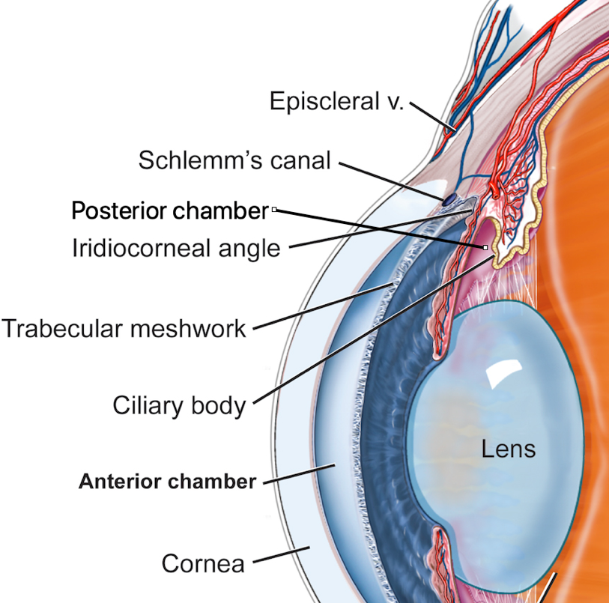

Glaucoma can be broadly separated into four classifications (see table 1).

1) PRIMARY ANGLE CLOSURE glaucoma, which is considered a sudden increase in the IOP caused by blockage of the fluid drainage from the eye. This occurs at the pathway of fluid (aqueous humor) drainage at the trabecular meshwork located in the angle of the eye formed by the base of the iris where it meets the cornea. The iris actually blocks and stops the drainage of aqueous from the eye. The sudden rise in the IOP can lead to rapid loss of vision. The eye becomes red, the pupil is mid dilated, the patient can have significant pain in and around the eye and nauseous and vomiting. There is also hazy, foggy vision and halos around lights. This is a true emergency and should be treated quickly.

2) CHRONIC OPEN ANGLE glaucoma is the most common form in the United States. It is thought that there may be an over production of fluid in the eye or a reduced egress or drainage of the fluid from the eye. Generally, the IOP maintains a steady state with only small fluctuations in the eye during the day for most people. In CHRONIC OPEN ANGLE glaucoma there is a slow gradual rise in the IOP over time, and the patient will not have any symptoms if there is not a complete eye exam undertaken this condition will be missed and the patient will have a gradual loss of peripheral vision. This is the most common form of glaucoma.

3) SECONDARY GLAUCOMA may be a combination of open and closed angle glaucoma, narrow angle glaucoma, intermittent angle closure glaucoma or the increase in IOP maybe a result of injury or a specific disease state such as iritis, uveitis which interferes with the outflow of the aqueous from the eye. Some disease states can cause new blood vessel formation, (neovascularization) of the iris and the angle structures which interfere with aqueous egress from the eye as an example diabetes or central retinal vein occlusion.

4) CONGENITAL or JUEVENILE glaucoma, glaucoma as a result of genetic or malformation of the eye. This form of glaucoma results in a condition called BUPHTHALMUS. This is an enlarging of the infant eyeball caused by the increased pressure in the eye. The infant eye is much softer and easier to distend.

Table 1
Type of glaucoma. Cause patient symptoms consider
Acute narrow angle | Total blockage of the drain area | PAIN, nausea, vomiting, hazy vision, halos | Emergency prompt treatment needed to prevent permanent vision loss
Open angle | Gradual buildup of IOP loss of peripheral vision gradual | Usually none until vision affected | Slow progression unnoticed by patient
Secondary | Injury, disease state, scar, inflammation | Due to cause | Progress slowly or rapidly
Congenital- infantile | Genetic abnormality of the eye | Large eyes, photophobia, excessive tearing, cloudy cornea | Should be noted soon after birth to treat and prevent permanent vision loss

NARROW ANGLE GLACOMA is more common in Asian populations and females. The eyes of these patients appear normal except for what is termed a shallow anterior chamber with the iris bowing forward at the angle. Crowding of the angle structures can cause the angle to become blocked by the iris and prevent the outflow of aqueous from the eye. At times the formation of a cataract will cause the crystalline lens to swell which pushes the iris forward blocking the angle. The problem is that in dim light the iris dilates and then in normal light the iris becomes more miotic (smaller) and can become hung up on the cataractous lens causing the iris to balloon up into the angle and closing the angle. (see figure 2)

Figure 2

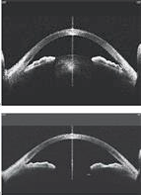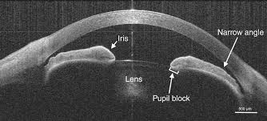
Iris bowing forward blocking the angle as seen in this tomography

Removal of the cataract allows the angle to open and the iris falls back to normal position

The typical complaints of halos and cloudy vision arise from the increase in IOP these symptoms will usually be noted after the IOP rises above 40 mmHg and get cloudier as the IOP continues to rise at times over 60 mmHg not uncommon. The systemic effects are also noted as the IOP continues to rise. The peri orbital area and eye pain; nausea and vomiting also increase in severity as the IOP rises.

The treatment for NARROW ARNGLE CLOSURE glaucoma is laser peripheral iridotomy performed expediently. The longer the attack the more chance of loss of vision. Usually a neodymium YAG laser is utilized to perform the laser procedure of creating iridotomies in the iris. Generally, the uninvolved eye is treated at the same time or soon after to prevent prophylactically the narrow angle attack in the fellow eye. (see figure 3)
Figure 3

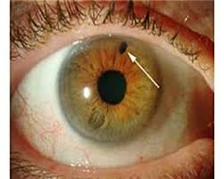

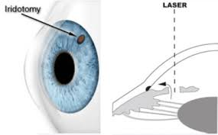

Gonioscopy is used to evaluate the angle and structures inside the eye, iris, trabecular meshwork and determine whether the angle is open or capable of suffering an acute narrow attack.

OPEN ANGLE GLAUCOMA is the most prevalent type of glaucoma encountered in ophthalmic practices. It is generally an insidious bilateral disease with little signs or symptoms noted by the patient until vision loss occurs. Diagnosis of this condition is based on 1) elevated pressure for the eye in question; 2) increased cupping of the optic nerve; 3) visual field loss. The condition is related to an inability of the aqueous fluid to drain normally from the eye at the level of the trabecular meshwork and Schlemm’s canal. There may be an accompanying over production of aqueous. Some patient have low IOP but lose vision due to other factors around the optic nerve that cause vision loss.

Some patients have a higher than normal intraocular pressure but no increase in cupping and/or no visual field loss. These patients are classified as OCULAR HYPERTENSION. This some practitioners consider glaucoma suspect or pre glaucoma. Some patients may have elevated IOP for years and tolerate the high IOP with no cupping or visual field loss. However, over time many of these patients go on to develop glaucoma with loss of vision. This condition needs to be followed carefully and evaluated more than once a year. Changes in the optic nerve cupping indicates that the patient is more likely to progress to vision loss. (see figure 4)

Figure 4

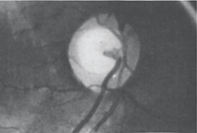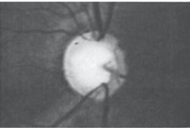
Note the thinning of the rim. 360º on the right.
A sign of glaucoma the optic nerve is not
tolerating the measured IOP

Open angle glaucoma is treated with topical drops to lower the IOP. There are laser procedures that can also lower the IOP for most patients. The most common laser for open angle glaucoma is called a “gentle laser”; selective laser trabeculoplasty. This is an argon pulsed laser that treats the trabecular meshwork without causing laser burns and damage to the tissue. Most patients are assigned an IOP that is the target IOP for each eye to lessen the chance of vision loss. This pressure is usually set at less than 20 mmHg. At the present time studies have shown that an IOP of 12.3 mmHg or less will lessen the visual field loss, but most patients have an IOP set for the eye that maintains the vision and does not show progression of cupping. Glaucoma is a disease that needs to be monitored and carefully evaluated to prevent vision loss, not only measurement of the IOP but evaluation of increased cupping with sequential optic nerve photos, scanning laser evaluation of the retinal nerve fibers around the optic nerve for thinning that would indicate loss of nerves and possible vision loss but also a visual field examination at least yearly to assure that there are no further loss of field.

The Humphrey visual field is now considered to be the gold standard to evaluate peripheral field and any changes or progression in field loss. There are several peripheral visual field loss defects that can be encountered early on with glaucoma. The nasal step, either superior or inferior and arcuate defects inferior or superior. (see figure 5 and 6)

Tonometry to measure the intraocular pressure is tantamount to first line of defense in preventing field loss. Usually patients are evaluated every 3-4 or 3-6 months depending on the extent of the glaucoma and control of the IOP. The use of topical medication in the form of drops is a means for controlling the IOP in patients with open angle glaucoma. Compliance with the use of drops is important, unfortunately many patients forget or since there is no pain or symptoms fail to use the drops and suffer additional vision loss.

When patients are non-compliant, this is an indication for use of the laser as a mechanism to achieve the desired IOP. The SLT (scanning laser trabeculoplasty) has no untoward side effects and over 95 % of patients achieve their target IOP. The laser may have to be repeated usually in 1-2 years to maintain the desired IOP. Since there is no damage to ocular tissue this can be repeated as needed to maintain the IOP.

Drops can be a bother. They cost money, sometimes significant dollars even with insurance coverage, and for people on fixed monthly income the cost can become a major stumbling block to compliance. Patients do not like to put drops in their eyes. Even drops only used one time every day are often forgotten and missed, and many drops are used two times a day or BID. Drops also have side effects that can be local or systemic. Local side effects can be burning, stinging, redness, blurry vision and some (prostaglandin derivatives) can change the color of the iris brown especially if the iris color states out hazel and can cause the eyelashes to grow longer and darker. Some patients using these drops for many years notice a grey color around the lids and loss of fatty tissue in the lower lids.

Systemic effects can cause slowing of the heart rate in some individuals, breathing difficulties and are contraindicated in asthmatic patients (beta blocker drops). Drops over time affect the ocular surface, conjunctiva and cornea leading to increased complaints of dry eye and it is thought that they affect surgical outcomes for both cataract and glaucoma procedures due to the changes in the ocular surfaces caused by the topical anti-glaucoma drops. Benzalkonium chloride (BAK) a preservative that is used in most eye drops is thought to be a major contributor to the disruption of the ocular surface.

SECONDARY GLAUCOMA occurs due to some disease or injury to the eye causing a disruption in the production or usually the drainage of the aqueous from the eye. The disease or injury make the secondary glaucoma more difficult to manage and treat requiring, topical medication and more frequently surgical intervention, laser or invasive surgery to maintain proper IOP. There are conditions that lead to a secondary angle closure type of glaucoma such as: 1) synechiae, anterior or peripheral scar tissue formed between the iris and the trabecular meshwork in the angle the most common cause is intermittent angle closure glaucoma; 2) posterior synechiae formed between the posterior iris and the crystalline lens. (usually as a result of chronic iritis or uveitis). 3) dislocation of the crystalline lens which can occur from injury/injury, genetic disease (such as Marfan’s), resulting in the lens/iris diaphragm blocking the trabecular meshwork and angle; 4) conditions of the crystalline lens that result in swelling of the lens and forward movement of the lens/iris diaphragm, such as penetrating injury or rupture of the lens capsule, hypermature cataracts which swell.

Some other causes of secondary glaucoma are related to the invasion of the angle and trabecular meshwork by neovascularization (new blood vessels growing) of the angle causing scaring and blockage of drainage. This can be caused by central retinal vein occlusion and diabetes both due to ischemic disease of the eye. Tumors of the iris, choroid, cilliary body can invade the angle while growing or simply cause obstruction of the angle and trabecular meshwork.

CONGENITAL GLAUCOMA is rare, but the signs and symptoms of this glaucoma are very characteristic of the disease and usually easily noted by parents and pediatricians. Generally, parents become aware that there is a problem with the babies’ eye within several weeks of birth. The child is very sensitive to light (photophobia) and can be tearing profusely. The cornea is hazy and cloudy due to edema of the tissue caused by the high IOP. The eyes become enlarged or buphthalmic with the corneas measuring 2-3 mm larger than normal. Hazy enlarged corneas are very characteristic of congenital glaucoma. Excess tearing when encountered in a child should be evaluated glaucoma but most commonly is caused by a blocked tear duct termed dacryocystitis.

Important points to remember are that once vision is lost due to glaucoma there is no way to get it back. Most glaucoma can be managed to maintain the present state of vision, but the patient needs to be a partner to control the condition on a daily basis in use of medication and following recommendations for follow-up visits. Angle closure glaucoma is best treated with surgery, usually laser peripheral iridotomy. Open angle glaucoma can be managed with topical medication and/or surgery. Even with normal or low IOP it is possible for patients to lose vision due to other disease factors affecting the optic nerve. The importance of early detection lessens the risk of vision loss and cannot be over emphasized the need to have yearly complete eye exams to uncover the so called “SNEAK THIEF OF VISION”.

Click Here to Complete the Glaucoma Quiz

Glaucoma Questions

- Once there is a diagnosis of glaucoma the patient will lose vision.
  - Only if not treated.
  - If they are not compliant with medication use
  - If the pressure is 20 mmHg or less
  - BOTH a and b

- Acute angle closure glaucoma is best treated by;
  - Massage of the eye
  - Oral medication to relieve pain
  - Laser surgical peripheral iridotomy
  - None of the above

- Angle closure glaucoma
  - Has no symptoms so the patient is not aware of the attack
  - Usually has an IOP of 20 mmHg or less
  - May cause severe pain, nausea and vomiting
  - None of the above

- Glaucoma has been called the “Sneak thief of vision” because
  - There is a significant amount of pain
  - The vision is hazy
  - There are halos around lights
  - There is no pain or symptoms of the disease noted by the patient

- Open angle glaucoma is more common in
  - Persons over the age of 40
  - In the USA
  - Those with a family history of glaucoma
  - All the above

- Angle closure glaucoma is caused by
  - Blockage of the cilliary processes
  - The trabecular meshwork blocked by the iris
  - Halos and hazy vison
  - High IOP

- Excess tearing in an infant is most commonly caused by
  - Infection of the lids
  - Glaucoma
  - Dacryocystitis
  - Bright lights

- Secondary glaucoma are due to
  - Injury
  - Iritis
  - Cataracts
  - Mainly high IOP
  - Choices a-b-c

- Glaucoma is a disease condition of
  - The optic nerve of the eye
  - Due to an IOP that is too high for that eye
  - Causes reversable loss of vision
  - Causes loss of retinal nerve fibers
  - Choices a-b-d

- Chronic open angle glaucoma is
  - Treated with topical drops to lower the IOP
  - May have laser surgery to control the IOP
  - May have laser peripheral iridotomy to control IOP
  - Choices a & b

- Visual field loss in glaucoma is
  - A sign that the IOP is too high
  - That the patient is having pain in the eye
  - That the patient maybe non-compliant
  - Choice a & b
  - Choice a & c

- Medical conditions like diabetes and central retinal vein occlusions are
  - Secondary forms of glaucoma
  - Are easier to treat
  - Do not cause loss of vision
  - None of the above

- The best way to see if you have glaucoma is
  - Have yearly exams to check
  - Look at your risk factors like IOP and family history
  - Be sure you have good vision
  - You do not have to be concerned if you have no eye pain and good vision
  - Choices a & b

- Congenital glaucoma has all but
  - Halos around lights
  - Excess tearing
  - Cloudy cornea
  - Large cornea
  - Photophobia

- Glaucoma has hallmarks of
  - Disease of the optic nerve
  - Increased cupping of the optic nerve
  - Usually increased or elevated IOP
  - Loss of visual field
  - All of the above
  - None of the above

- Gonioscopy is
  - Used to measure the IOP
  - Used to check the angle
  - Used to evaluate the visual field
  - Used to check the vision

- Tonometry is used to
  - Measure the angle of the eye
  - Evaluate the IOP
  - Evaluate the visual field
  - Maintain the IOP
  - Lower the IOP

- Primary angle closure glaucoma is characterized by
  - Total blockage of the drain system of the eye
  - Sudden rise to high IOP
  - Pain around the eye and brow
  - Halos and hazy vision
  - Nausea and vomiting
  - None of the above
  - All the above

- Patients with open angle glaucoma
  - Do not suffer vision loss
  - Usually unaware they have it until found on routine eye exam
  - Have pain around the eye
  - Always need a laser procedure
  - None of the above

- The loss of vision in glaucoma is
  - Peripheral then central
  - Can be reversed with drops or laser
  - Evaluated by gonioscopy
  - Found by doing Humphrey visual field
  - Both a & d

KEY

- D
- C
- D
- D
- D
- B
- C
- E
- E
- D
- E
- A
- E
- A
- E
- B
- B
- G
- B
- E

